Experts Made A Miraculous Discovery At Mount Zion That Proves A Biblical Story Really Took Place - part 1 of 4
By Suzi Marsh August 29, 2019
From my AOL “welcome page” of “news” items. As I copied and pasted and the pictures and explanation, it is 40 pages, BUT, there is only ONE paragraph to go with each picture on each page And most of it is “above normal size type, except for the direct quotes from the KJV and ASV Bible texts referred to..
http://absolutehistory.com/anthropology-and-history/archaelogy/experts-miraculous-discovery-mount-zion-biblical-story/?l=a&utm_source=AOL.com&utm_medium=Referral&utm_campaign=Direct
Biblical history verified by archeologists in 2019! [see p.23-24 below, on the original Word document, copied and pasted from AOL’s Welcome / news page, Sept 30, 2019]
“I like to think that we are excavating inside one of the ‘Great Man’s houses’ mentioned in the second book of Kings 25:9,” he explained to the Daily Mail. [see p.37 below, on the original Word document, copied and pasted from AOL’s Welcome / news page, Sept 30, 2019]
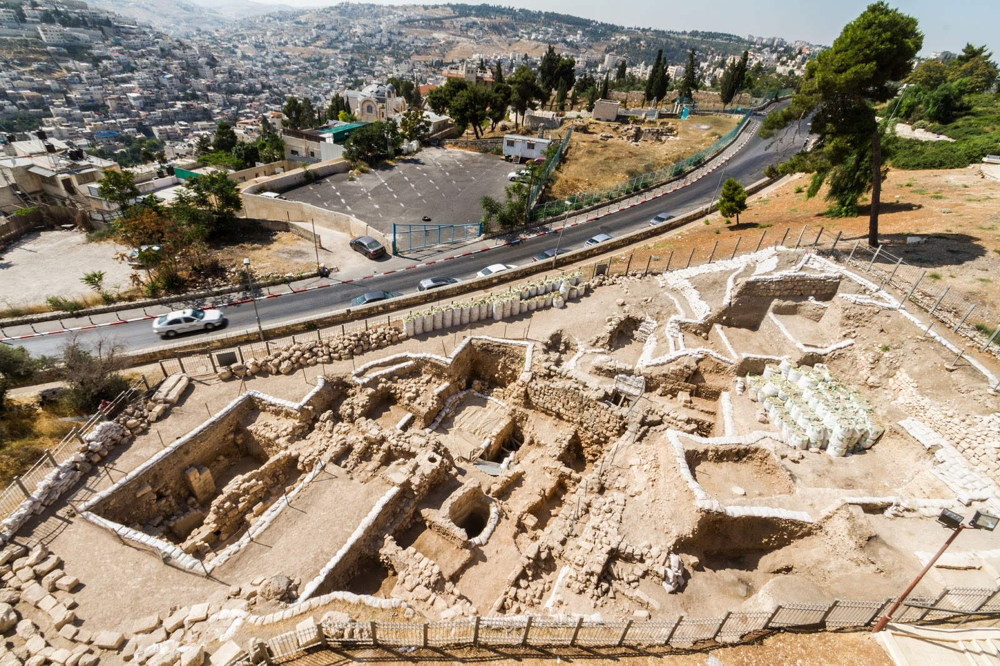Image: Mount Zion Archaeological Project Graicer
At Mount Zion in Jerusalem, a group of archaeologists are slaving away in the Middle Eastern heat. And as the team go, they pick through thousands of years of history in a bid to find something significant. Their efforts aren’t in vain, though, as ultimately they’re rewarded with an incredible find – something that may just prove a story from the Bible actually once took place.
Image: SeanPavonePhoto/Getty Images
It’s perhaps no surprise that the archaeologists struck pay dirt, either, as in the sixth century B.C., a great city – one described in the Bible as a place rich in culture and wealth – stood at the location. And even today, Jerusalem hosts a number of historic sights that provide a window into the area’s past. But because many stories have been told about this land, it sometimes takes an expert to separate fact from fiction.
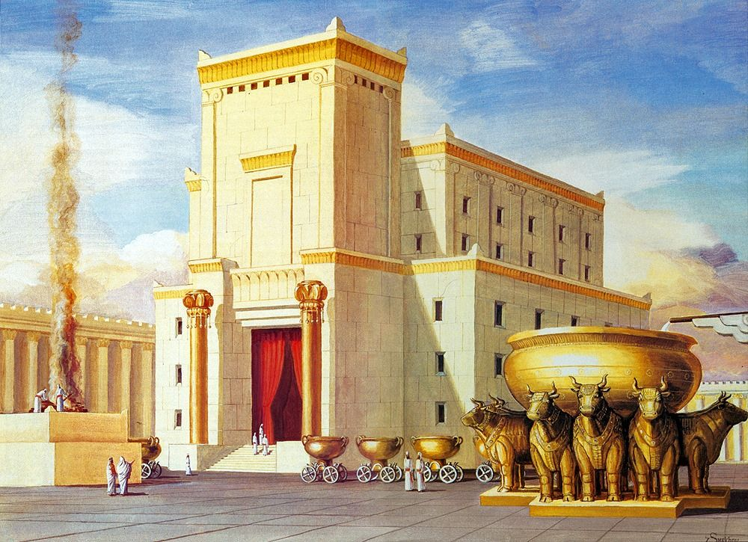Image: Israel Truths
According to the Bible, Jerusalem fell when the Babylonian king Nebuchadnezzar II unleashed his wrath on the Judean king Zedekiah in around 586 B.C. And in the chaos, it’s said, much of the city was destroyed. Even the mighty King Solomon’s Temple was apparently demolished – sparking an archaeological mystery that continues today. But how much of this legend actually has its basis in fact?
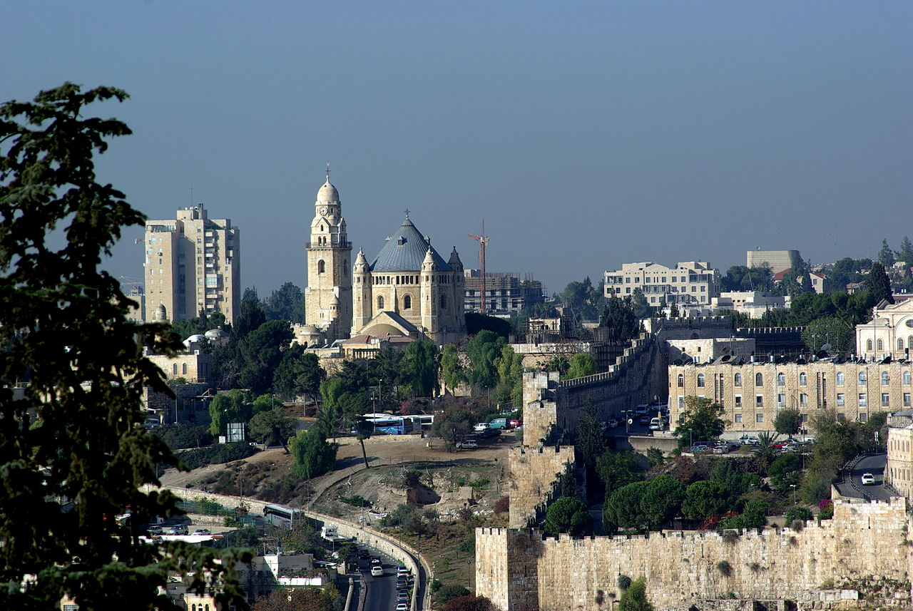Image: Berthold Werner
Well, before answering that question, it’s worth looking at exactly where the archaeologists’ dig took place. Today, the name Mount Zion is used to refer to an area of Jerusalem known as the Western Hill. Situated in the vicinity of the Old City’s ancient walls, this mound is where many modern excavations take place. And according to some, Mount Zion is the site where the biblical King David constructed his palace.
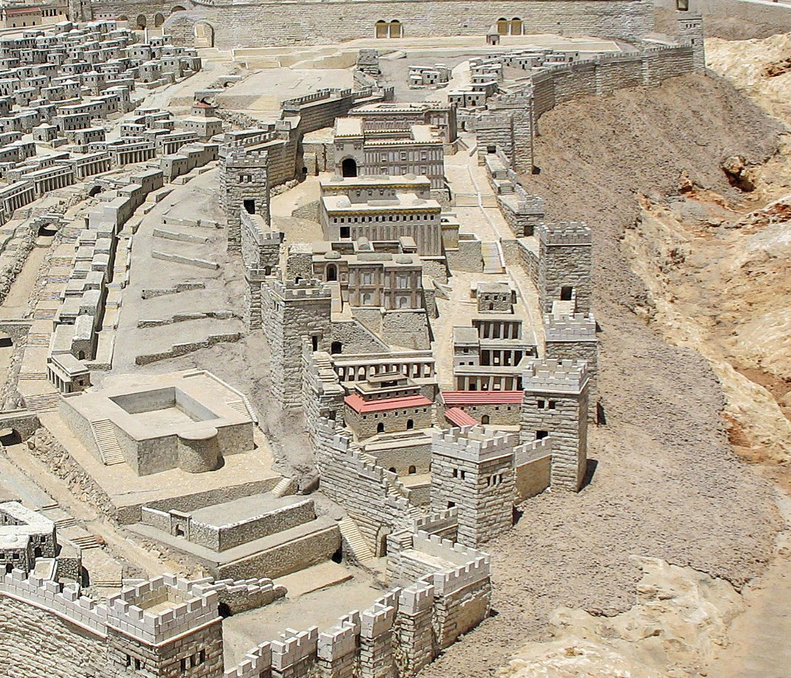Image: Ariely
Jerusalem itself, meanwhile, was first inhabited in around 4,500 B.C. and has seen many changes since, as a succession of invaders conquered its borders. But while history tells us the story of each population, the Bible gives a far more specific version of events. Apparently, the city was home to a community of Canaanite people in the 12th century B.C. – so, before King David arrived.
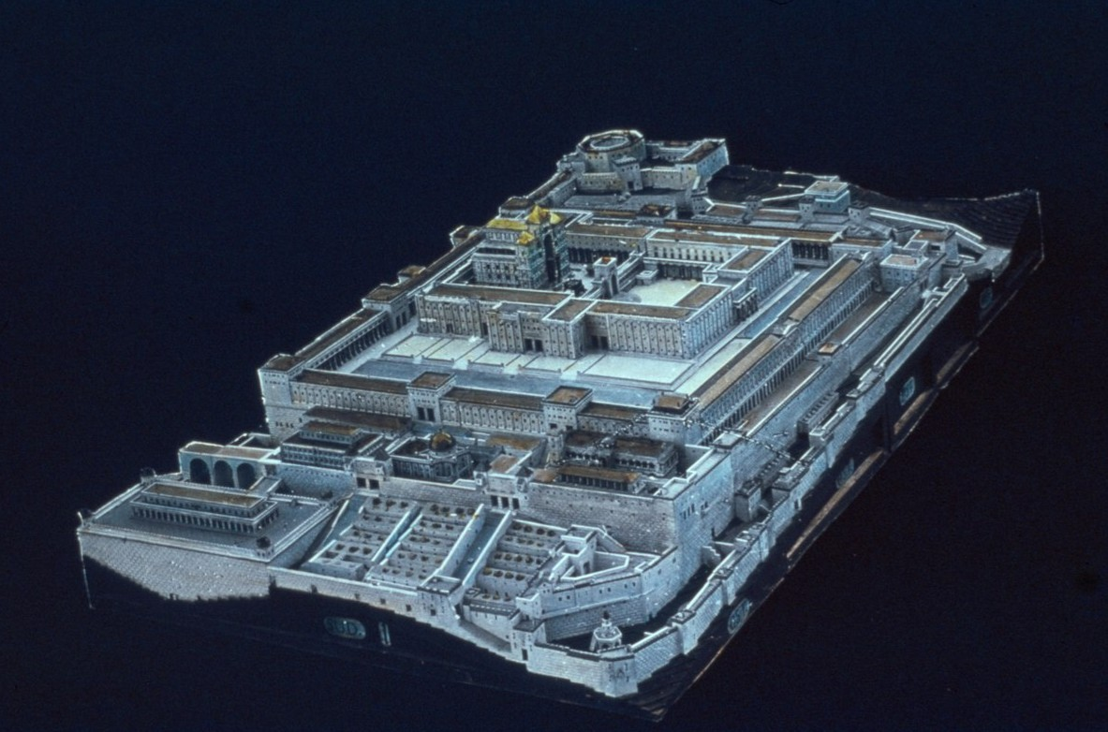Image: Matson Collection
Then, according to the Bible, in around 1,000 B.C. King David laid siege to Jerusalem and established his own city in its place. There, the leader built his fabled palace, and he declared that this new settlement would be the heart of the Kingdom of Israel. Later, David’s son King Solomon is said to have constructed his own grand temple on the same site.
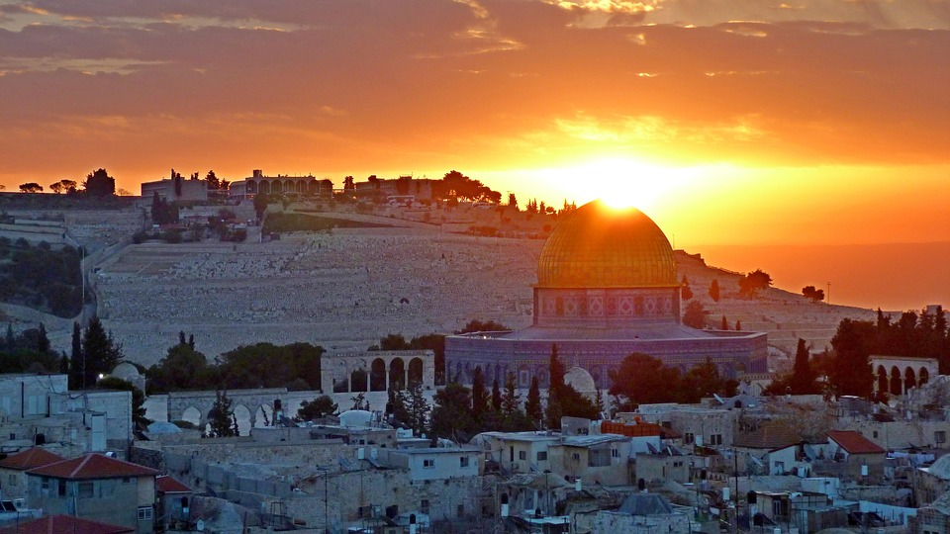Image: krystianwin
Nowadays, of course, Jerusalem is integral to a number of religions – not only Judaism, but also Christianity and Islam. As such, the city lies at the heart of the conflict that still rages in the Middle East. And because of this battle for sovereignty, some of the region’s history has become confused. In fact, Western Hill is among three sites that have been identified as Mount Zion over the years.
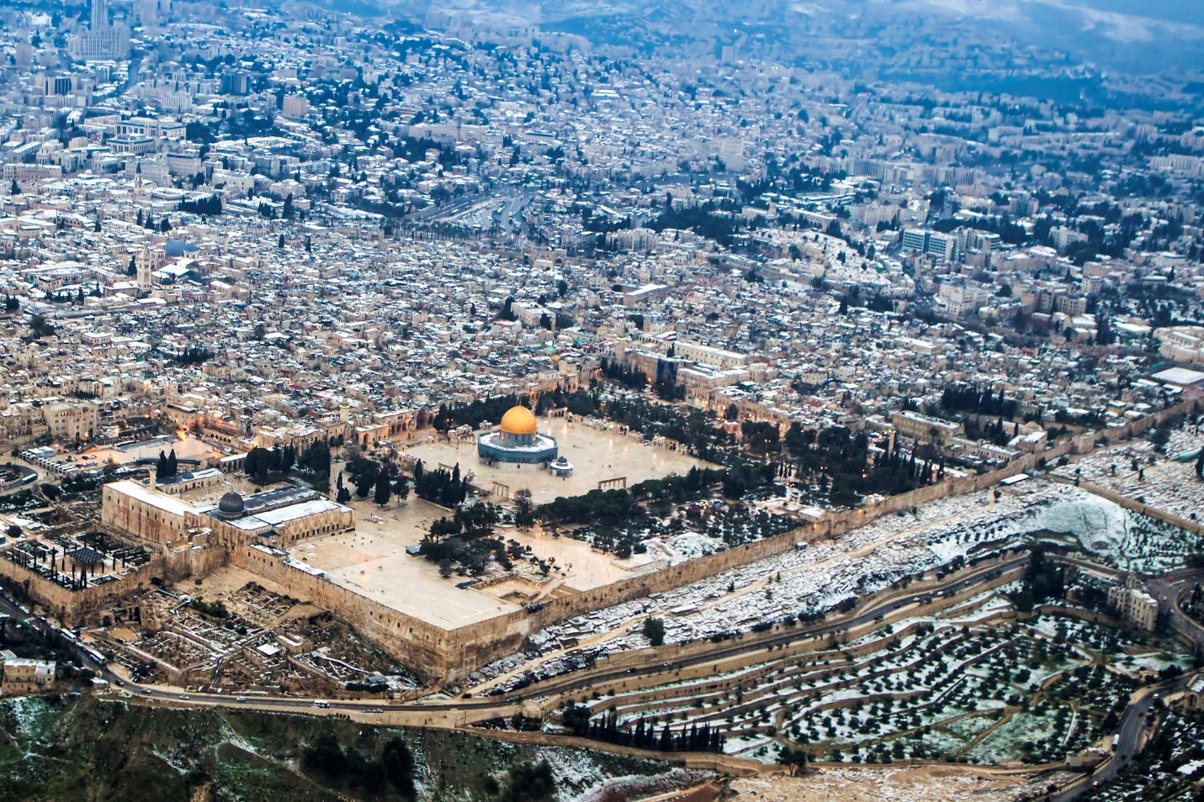Image: PhotoStock-Israel/Getty Images
One of these locations, known as Temple Mount, has been largely off-limits to archaeologists in recent times. Both the Western and Lower Eastern Hills, by contrast, have been subjected to numerous excavations. You see, many believe that the Western Hill contains the true relics of the biblical city – despite evidence that suggests the Eastern Hill was actually once the location of David’s settlement
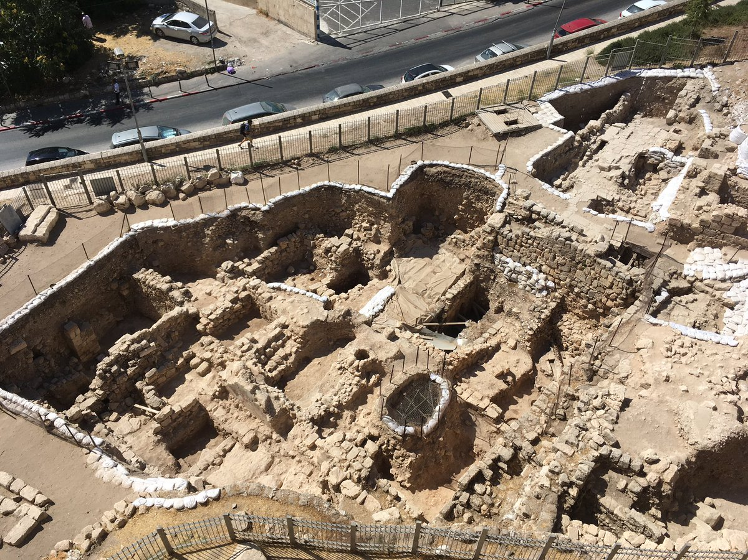Image: Twitter/Dr Rebekah Welton
Furthermore, today’s Mount Zion has been a hotbed of excavation since at least the 19th century. And in 2007 the University of North Carolina at Charlotte (UNCC) launched its own Mount Zion Archaeological Project – the first scheme of its kind by an institution from outside Israel. Since then, each summer season has yielded fascinating finds that help to tell the story of this ancient city.
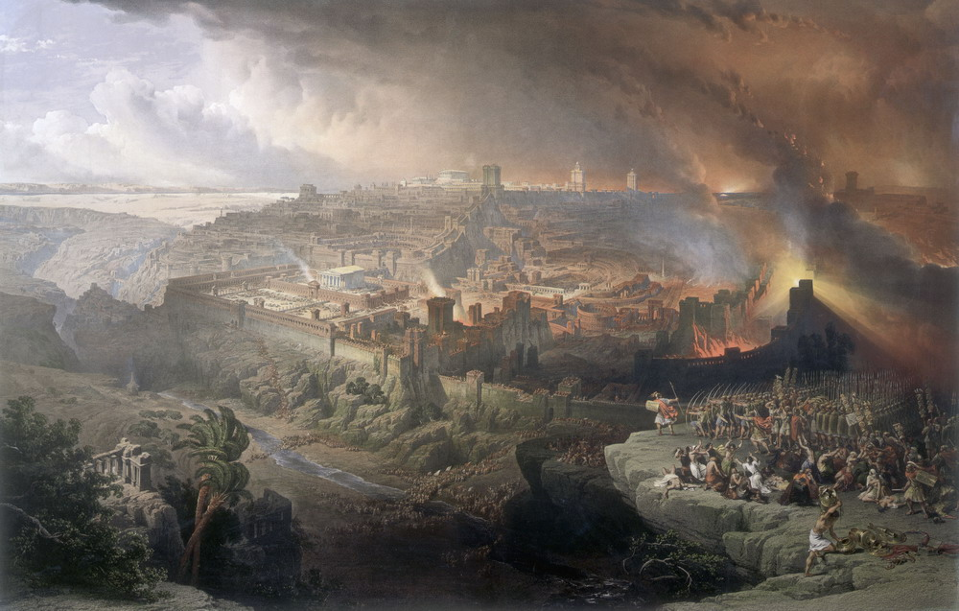Image: David Roberts
In 2016, for example, UNCC archaeologists unearthed an ancient coin at Mount Zion that is thought to hark back to 56 A.D. Featuring the face of Emperor Nero, the discovery seemingly proved that the Romans had been in Jerusalem some 14 years before they sacked the city. According to researchers, the coin had also likely made its way into one of the wealthy Jewish homes that once existed there. But this is far from the only significant find that the UNCC team have made at Mount Zion.
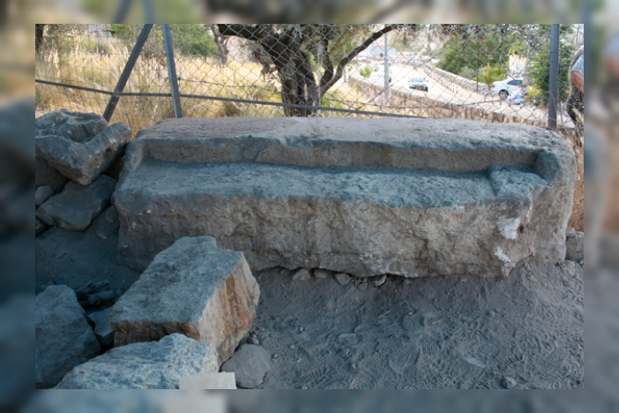Image: Mount Zion Archaeological Project
During one season, you see, the archaeologists uncovered a cup forged from stone that had been inscribed with Hebraic letters. Sensationally, the script on the item was the same as that on the Dead Sea Scrolls. Elsewhere, the group also excavated part of a gate that is said to date back to the time of the Crusades.
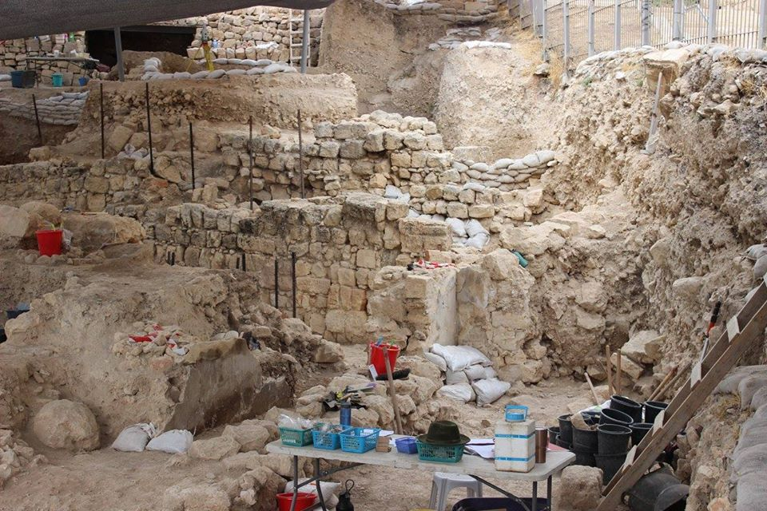Image: Facebook/Mauney Memorial Library
Then, on August 11, 2019, the project’s members had an exciting announcement: while excavating at Mount Zion, they had made a string of discoveries linked to the time of the First Crusade. Beginning in 1095, this turbulent period saw Christian armies descend on Jerusalem in an attempt to reclaim the region.
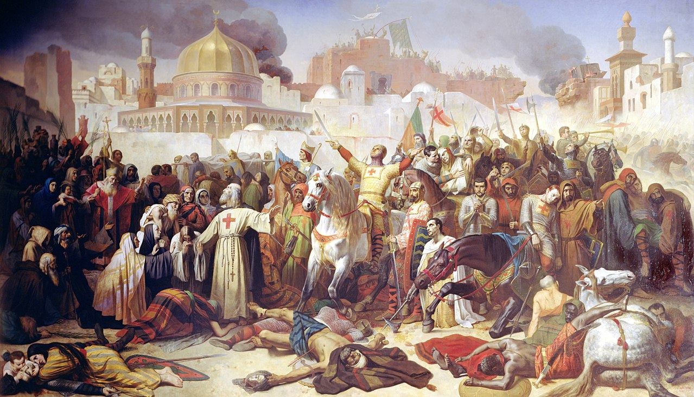Image: Émile Signol
Before the First Crusade, the Holy Land had been under Islamic control since around the seventh century A.D. But after four bloody years, the Christians ultimately wrestled control of the region and took Jerusalem in 1099. And in modern-day Mount Zion, archaeologists discovered evidence that gave them a fascinating insight into how this 11th-century skirmish had played out.
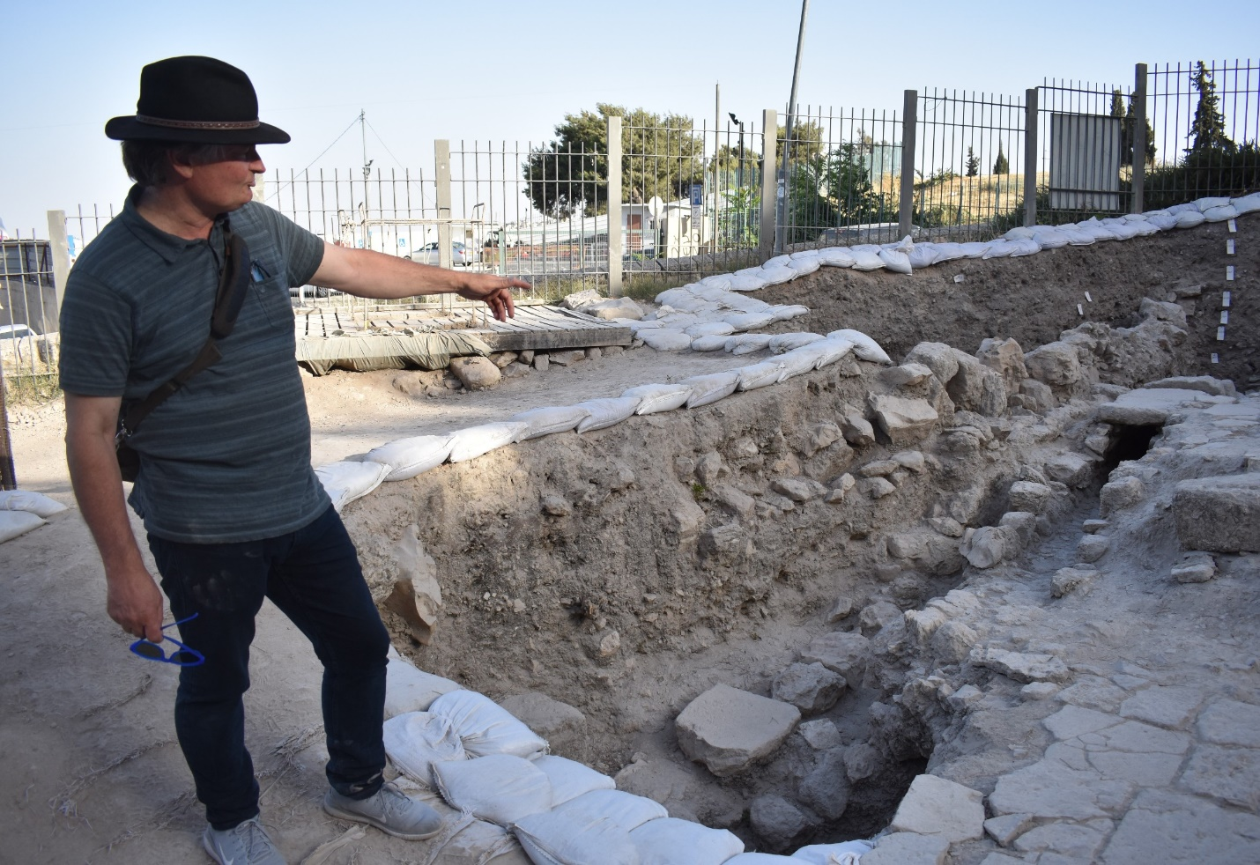Image: Mount Zion Archaeological Project
Historically, one account of the siege claimed that the Crusaders were initially foiled by a low ditch around the city. When one military leader pledged gold coins to any soldier who would help block the ditch with stones, though, he had several takers. And although this story is often dismissed as fiction, archaeologists at Mount Zion discovered what they believe to be reliable proof of the tale’s veracity.
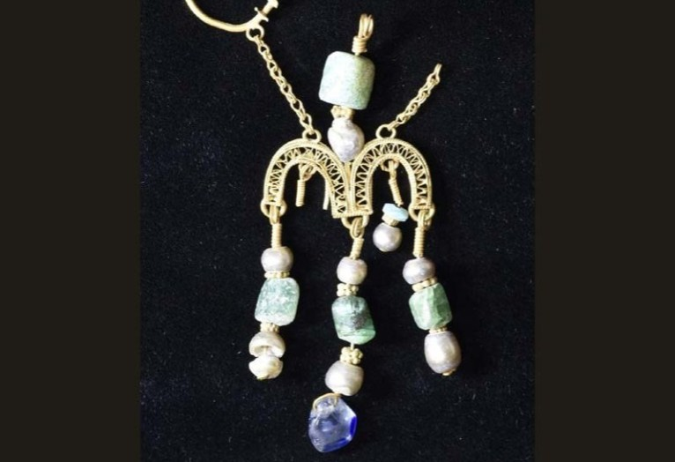Image: Mount Zion Archaeological Project
For one, the group found a filled-in ditch that seemingly matched the one in the legend. Intriguingly, an ornate piece of jewelry was also unearthed at the location, with the item believed to have belonged to one of the Fatimid Muslims who defended Jerusalem against the Crusaders. And because the trinket was found amongst Christian artifacts, archaeologists are certain that both it and the ditch are relics of the 1099 siege. Yet these were far from the most important discoveries made at Mount Zion during 2019’s summer season.
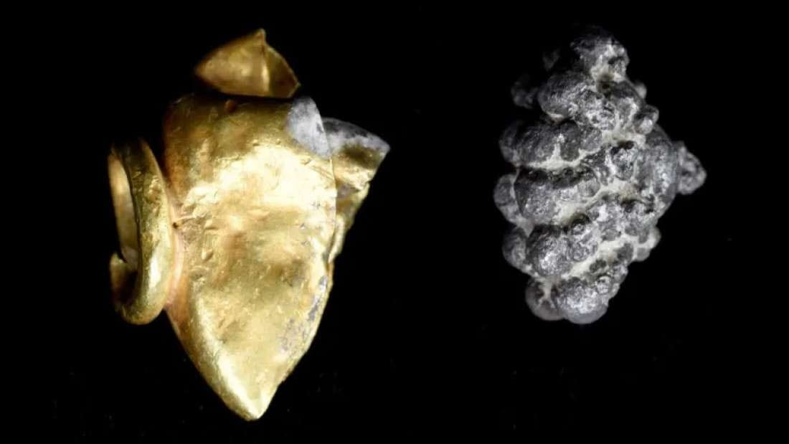Image: Facebook/Hannah Cohen Gross
On the same day, you see, the team announced another incredible find. While excavating the Western Hill, they had uncovered another stunning piece of jewelry that may go on to shed new light on a turbulent period in the history of Jerusalem. What’s more, the artifact appears to date back to 1,700 years before the time of the first Crusade.
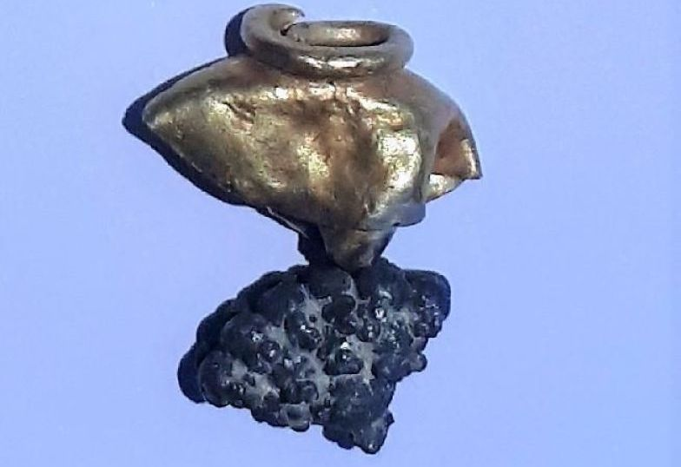Image: Mount Zion Archaeological Project
Crafted from gold and silver, the piece – a tassel or earring – was obviously of great beauty and value at the time. The decorative treasure features a bell-like upper section as well as a lower part modeled on a bunch of grapes. And even though the item has warped and distorted over time, it remains stunning.
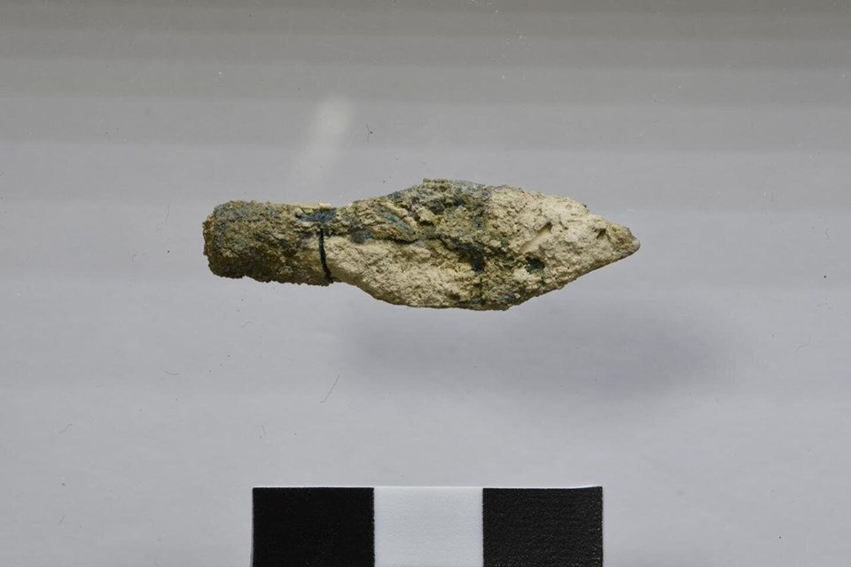Image: Facebook/Tour Israel With Rebecca
Interestingly, though, the jewelry wasn’t the only thing that the dig site revealed. According to UNCC, archaeologists also discovered significant deposits of ash as well as household items such as lamps and pieces of pottery. A number of arrowheads were also uncovered in the same area.
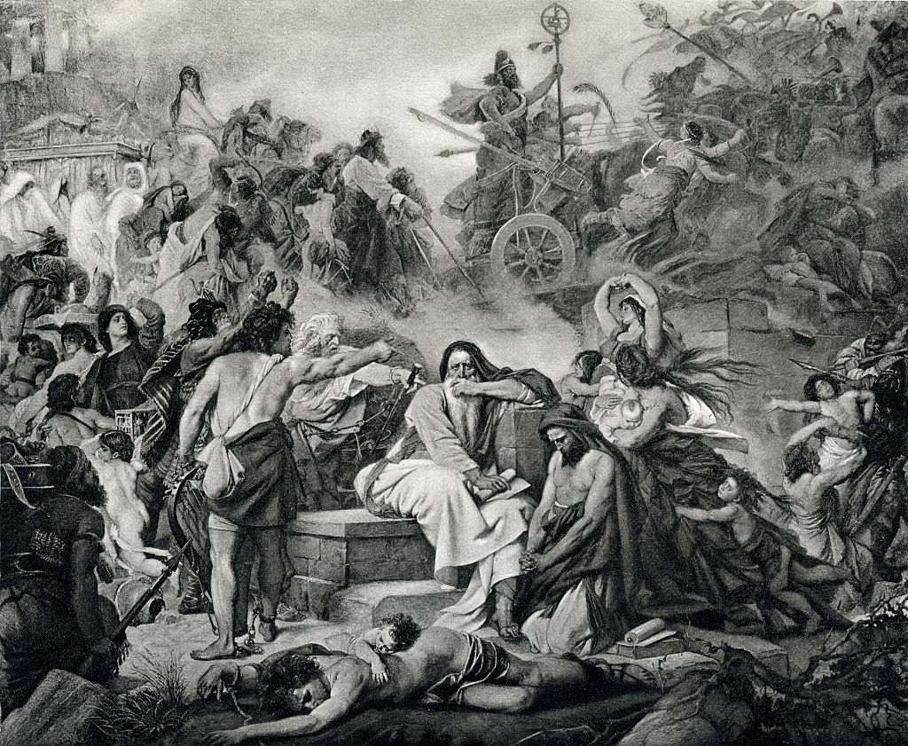Image: Culture Club/Getty Images
And, together, these artifacts allowed experts to date the site to around 586 B.C. – a significant point in the story of Jerusalem. Crucially, at that time, the Babylonian King Nebuchadnezzar II laid siege to the city, leaving a trail of destruction in his wake.

